Using a drawing tool, like Draw.io or Visio, draw the different logical layers of a web based .NET application. For each logical layer, describe what .NET technologies could be used, the role of the layer, and how a layered architecture helps solves separation of concerns. Comment on at least two of your classmates' posts.

There are multiple advantages when it comes to three-layer .net architecture based web applications. While reading, the one advantage that stuck out to me the most is that it is easier to distribute the workload in this type of architecture. Because the code is organized into different layers based on its responsibility, each member of the team can code independently which helps the developers control the workload. Review the attached diagram to understand the three-layered system better.

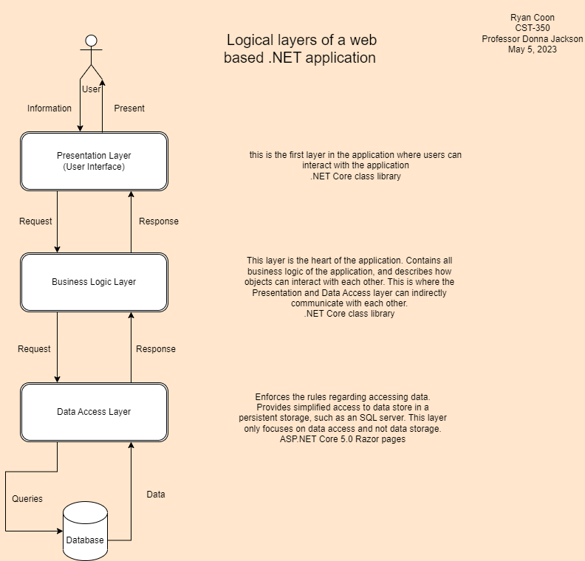

References:

Gewarren. (2022, April 7). Developing Web Applications with ASP.NET - .NET Framework. Microsoft Learn. https://learn.microsoft.com/en-us/dotnet/framework/develop-web-apps-with-aspnet

Khan, S. M. A. (n.d.). Three Tier Architecture In ASP.NET Core 6 Web API. https://www.c-sharpcorner.com/article/three-tier-architecture-in-asp-net-core-6-web-api/

Luu, U. (2022, May 27). How to build and deploy a three-layer architecture application with C#? Enlab Software. https://enlabsoftware.com/development/how-to-build-and-deploy-a-three-layer-architecture-application-with-c-sharp-net-in-practice.html